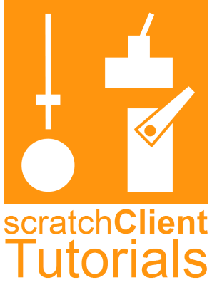Reproducing this at home

# Introduction

In today’s workshop you have done some physical computing, controlled from Scratch running on a Raspberry Pi 2B or 3B which interfaced with an Arduino Nano that controlled the servo, LEDs, buttons, a joystick and a buzzer. You may have done only a part of it.

You will most likely have used Scratch 2, but it can also be done using Scratch 1.4

# Getting the material

You can download the material from Github and install it.

What you have created in this workshop you can copy to a USB stick if you brought one.

## Download from Github when you are at home

You can find all material at: [www.github.com/hansdejongehv/scratchClient-Tutorials](http://www.github.com/hansdejongehv/scratchClient-Tutorials)

This includes the BoM (Bill of Material) for the boards that you used.

There is a script that you can download and execute from a Raspberry Pi connected to the internet.

To get this kicked off

1. Go to [www.github.com/hansdejongehv/scratchClient-Tutorials](http://www.github.com/hansdejongehv/scratchClient-Tutorials) or go to [www.github.com](http://www.github.com) and then:
   1. Click ***Explore*** on the top of the window
   2. Search for scratchClient-Tutorial.
   3. Go to the correct page.
2. Click the ***Releases*** link.
3. Select the latest release.
4. Look at the release notes to see how you have to install.
5. Open a command prompt the Raspberry Pi.
6. Copy the series of commands into terminal window
7. Reboot to make the icons visible.

Alternatively, you can use a blank SD card and copy an entire image on it that you can download from the same location.

# See instructions on YouTube

There are extensive instruction on Youtube. Go to [www.youtube.come](http://www.youtube.come) and search for   
 scratchClient Tutorials

There are instructions that go step by step through the slides of today, but also an video that shows how to buy the components.

# Downloading your work of today to your USB stick

1. Put your USB stick in the USB hub.
2. Copy the material you edited. All of that should be on the desktop.
3. Feel free to further copy any file you want.

# Questions, suggestions and remarks

If you have questions or remarks, feel free to contact us by email at

[hans.piam@hanselma.nl](mailto:hans.piam@hanselma.nl)

In case you have specific questions about scratchClient then you can directly contact

[heppg@web.de](mailto:heppg@web.de)

You can also pose your Scratch / scratchClient related questions on the forum of Raspberry Pi

<https://www.raspberrypi.org/forums/viewforum.php?f=77>

Be prepared that it may take a little while to get the answers, since we may be travelling.

Of course we love to hear from you whether you liked it or not and if you have suggestions for improvement in case we would run this workshop in future.

# Finally

We hope that you enjoyed the workshop. Have a safe trip home!